Dear Parents and Carers,

We are pleased to be welcoming your children back to school from the 8th March. We continue to take every measure to make sure our schools are as safe as possible, and as a city we continue to share learning and good practice across all schools.

Coventry’s current rate of 112 people with the virus for every 100,000 of the population, has significantly reduced, but continues to remain higher than when schools fully opened in September 2020. There are a number of additional measures that will be in place, linked to national guidance and local advice, and we thank you for your continued support with this.

Lateral Flow testing (LFT)

LFT continues to be an important tool in managing infection rates and reducing transmission on an ongoing basis. It is helpful in identifying asymptomatic cases, and therefore reducing the number of children and young people that may need to isolate.

It is already in place for secondary age pupils, who will be invited to have 3 tests on their return to school (3 to 5 days apart). Following this, home testing kits will be supplied for pupils to test twice weekly. Parental consent is required for testing, and we urge you to consent for your secondary-age child to be tested.

There is no national recommendation for primary-age pupils to have a LFT. You will be aware, however, that we have extended our LFT Community sites to be able to test children and young people from age 2. We are encouraging all parents and carers of children attending a primary school to take them for a COVID-19 test prior to their return to school week commencing the 8th March, and then on a weekly basis thereafter. Information on the location and opening times of LFT Community sites is available at https://www.coventry.gov.uk/lateralflowtesting.

Please also be aware that the government have just announced rapid lateral flow testing for households and bubbles of school pupils and staff. This will enable parents and carers to collect home test kits at a local collection point to allow LFT to be done at home. Further information is available at https://www.gov.uk/guidance/rapid-lateral-flow-testing-for-households-and-bubbles-of-school-pupils-and-staff. This is a new development and we will provide further information through your usual school communication process as soon as we have it.

Face Coverings

Secondary-age pupils will have already been used to wearing face coverings when moving around school premises and in communal areas on school sites. The Department for Education are also currently recommending that face coverings are worn by pupils in classrooms or during activities where social distancing cannot be maintained. Secondary schools in Coventry are adopting this advice and no doubt will have already been in contact with you in relation to this. In addition, any secondary aged pupils travelling on dedicated transport to school must also wear a face covering. This does not apply to any children or young people who are exempt from wearing face coverings.

There is no national or local recommendation that children in primary schools wear a face covering within the setting.

General Controls

There are a number of other things that you can also continue to do to help make our education settings safe. These are:

- Not sending your child to their nursery, childminder, school or college if they are showing coronavirus symptoms or someone within the household is showing symptoms
- Arranging a test if you or your child develops symptoms – no matter how mild – and informing the nursery, childminder, school or college of the result.
- Keeping your child at home where they have been identified as having contact with a confirmed case either in school or elsewhere
- Ensuring that the whole household isolate where a household member is awaiting a result, and continued isolation if test result is positive
- Reinforcing with your children how to wash hands, make space and minimise contact
- Adhering to the current rules and guidance (including additional mitigations in relation to Lateral Flow Testing and face coverings) to help reduce transmission.
- Supporting your schools by understanding and reinforcing with your children what is expected, including where they are required to wear face covering both in school and on public transport (including dedicated school buses)
- Adhering to the current rules when you pick up and drop off students at school sites, and ensuring you wear a face covering, maintain a 2 metre distance from other parents (including not blocking entrances, exits, or immediate areas outside of schools)
- Continuing to adhere to the national guidelines https://www.gov.uk/guidance/national-lockdown-stay-at-home

If you would like any more help and advice around COVID-19, please go to
https://www.gov.uk/coronavirus.

We are aware that there will continue to be situations across the city where children / young people are required to self-isolate because they test positive or are a contact of a confirmed case in an education setting. This is obviously a necessary precaution to prevent the spread of COVID-19 and keep Education settings open to as many children and young people as possible. Where pupils do need to self-isolate, schools will support them to continue with their education using remote learning packages.

We would like to thank you for your continued support in helping our city reduce COVID-19.

Yours sincerely,
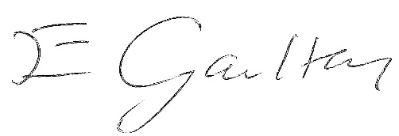
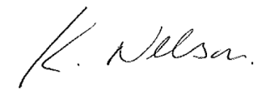

Kirston Nelson Liz Gaulton
Director of Education & Skills Director of Public Health and Wellbeing

